GAME PRODUCTION 2
FINAL REPORT

Number: N01295714
Full Name: Aidan Zizys
Title: Programming Leader / Test Engineer

- PRESENTATION OF WORK

Summary
As the programmer leader / test engineer of this project, I have mainly worked on maintaining the smooth flow of our teams, stepping in to fill holes where needed, and helping teams overcome challenges. I have also developed a set of automated testing tools that allow for easy testing and iteration on incomplete game components, and in many cases, I stepped in to help finish developing parts of the game. I also inserted myself into different leader teams, such as solutions and environment to help finish tasks that weren’t done or help undermanned teams that were overworked.

  - Achieved Programming Leader Work
- I stepped in when necessary to help teams complete tasks, moving us closer to a polished game
- I assigned tasks for 9 weeks
- I checked in with teams throughout the term

  - Achieved Test Engineer Work
- I have run 26 Test cases
- I have found 3 critical, 1 major, and 2 minor bugs
- I have created 2 test case documents (Documents are attached to submission)

  - Achieved Side Task Work
- Solution: I created the entire car solution at the beginning of the term (files attached)
- Environment: I maintained the code base, reorganizing and removing code where necessary, and maintained the health of the development and master branch along with Sujan
- Development:
  - I created the ability and stat pick up system, including the objects that can be picked up, the interface between them and the player car, and the car components which interface with the objects and the functionality behind the player car using those stats and abilities
  - I ported the networking code into the project and worked to make it functional, including resolving binary build issues, resolving project metadata issues, and connecting the networking into our code base, often rewriting code

- GOALS
  - Lead Programmer Goals
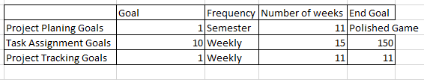

    - Polished Game: I believe that the prototype has polish in some areas, but in many areas is still lacking, and considering the vision we had for the game, there is still far the game can go.
    - Task Assignment: I assigned tasks until after week 8, where Ayyad took over the task because I was absent during the two weeks from the start of reading week until the end of week 8. Instead I moved on to helping in development spots where I felt I could help move the project along, as noted in my Achieved Side Task Work.
    - Project Tracking: I checked in with teams weekly until the end of week 8. I continued to check in with specific members of the project, such as making sure to help Sujan with the needs of the environment team, and with Michael with the needs of the networking team.

  - Test Engineer Goals
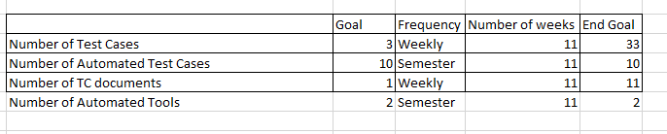
    - Number of Test Cases: I ran a total of 26 test cases, 7 short of my goal.
    - Number of Automated Test Cases: I coded a total of 6 automated tests which covered most of the test cases in the game.
    - Number of TC Documents: I only created two test case documents this term due to my time being used to create the solution as noted in my Achieved Side Task Work.
    - Number of Automated Tools: I did not create any automated tools.

